*USER’s MANUAL*

Medication Adherence Support System (MASS) Patient-Facing App

*Arnab Barua, Adam Hachey, Mark Mullison, Dominick Roselli, Jiankun Sun*

Table of Contents

1 Introduction 3

2 System Configuration 3

3 Getting Started 3

3.1 App Installation 3

3.2 System Overview 3

4 Using the App 5

4.1 Connecting to Medical Record 5

4.2 Setting Schedule to Take Medication 6

4.3 Dosage Reminder 7

4.4 Demographic Questionnaire 8

# **Introduction**

MASS Patient-Facing App is an Android application whose main function is to help remind patients taking medication on time and record patients’ medication adherence as well as other relevant information electronically via FHIR connection. This is a proof of concept to demonstrate the power of getting medication orders via FHIR to seed the medication admin schedule and to collect demographic information from patients to augment census and other information that could be used by researchers to understand medication adherence at the community level.

# **System Configuration**

MASS Patient-Facing App operations on mobile devices with Android operating system. Connection to Internet is required in order to interchange patient data between the application and the database on FHIR server. A user must have built a medical record profile on FHIR server to use this application.

# **Getting Started**

## **App Installation**

The Android project source for this application is available at: <https://github.gatech.edu/gt-hit-fall2016/Improving-Medication-Adherence>.

## **System Overview**

Figure 1 shows the application’s main menu, which include the following components:

* **MEDICATION ORDERS**: This button contains a list of user’s all medication orders. User can set reminder of taking medications in this tab.
* **MEDICAL RECORD CONNECTION**: This button is used to set connection to FHIR server in order to interchange patient data between the application and the database on FHIR server.
* **QUESTIONNAIRE**: This button is used to take a quick demographic questionnaire to help medical researchers are understand medication adherence at a community level.

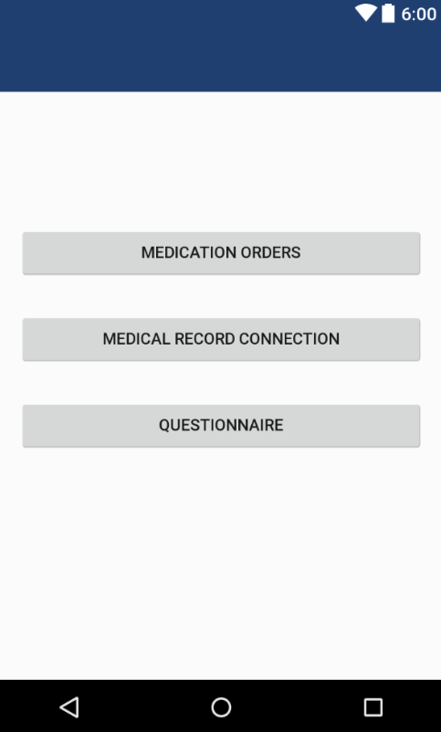

Figure 1: Main Menu

# **Using the App**

## **Connecting to Medical Record**

* Click **“MEDICAL RECORD CONNECTION”** in the main menu, and then the user will be navigated to the interface to set medical record connection.
* Input medical record name, patient ID, user name, password and FHIR server’s url.
* Click **“TEST CONNECTION”** to test whether a connection to the patient’s profile on FHIR server can be built. If the connection is successfully built, the button will turn to green and display **“SUCCESS”**.
* Click **the round green button in the bottom right corner** to save the current connection. If the connection is successfully save, a banner with “Connection Saved” will be displayed.

The main steps for connecting to medical record are illustrated in Figure 2.

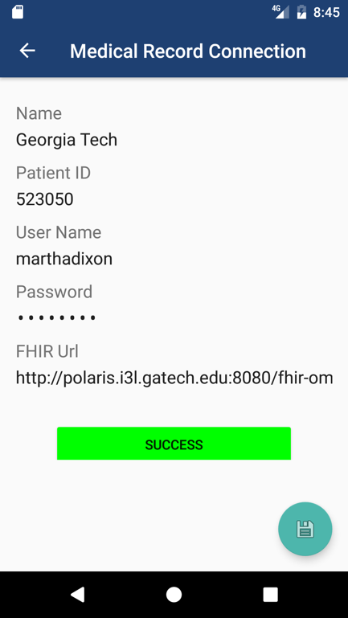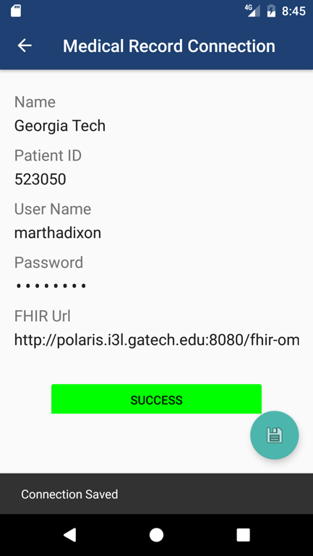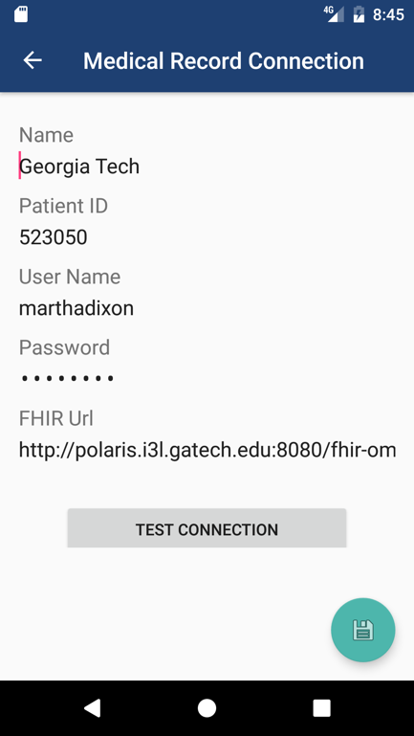

Figure 2: Connecting to Medication Record

## **Setting Schedule to Take Medication**

* Click **“MEDICATION ORDERS”** in the main menu, and then the user will be navigated to the list of all his/her medication orders.
* Select the medication which the user want to set time to take.
* Input the time to take medication **on the red line**. The time format should be “HH:MM” (24-hour time).
* Click **“Save” in the top right corner** to save the schedule. Otherwise, click **“Cancel” in the top left corner** to cancel setting schedule. The user will then be navigated to the list of medication orders in both cases.

The main steps for setting schedule to take medication are illustrated in Figure 3.

Figure 3: Setting Schedule to Take Medication

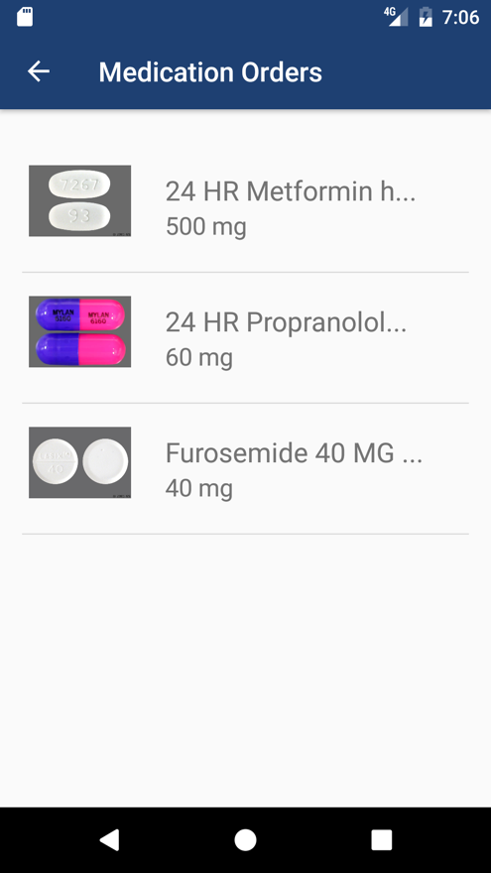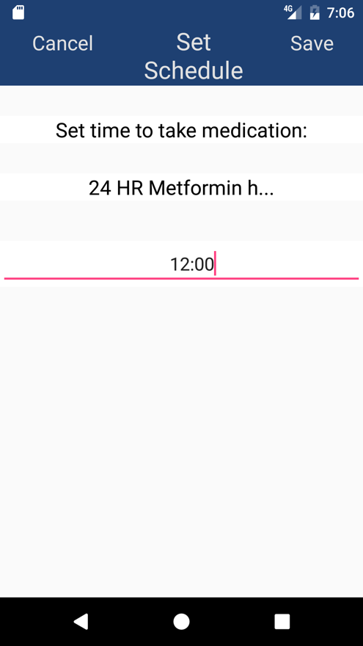

## **Dosage Reminder**

* The interface of dose reminder will pop up when it comes to the time which the user set to take medication, as shown in the left screen shot in Figure 4.
* The user will choose one of the three alternatives for taking medication:
  + **“TAKE”**: The user will take the medication right now on time.
  + **“REMIND ME IN 15 MINS”**: The user will take the medication later and let the application remind the user again in 15 minutes. If this is selected, the dosage reminder will pop up again in 15 minutes.
  + **“SKIP”**: The user will skip the medication this time. If this is selected, the user will be navigated to a survey where the user needs to choose a tab to report why the medication is skipped, as shown in the right screenshot in Figure 4.

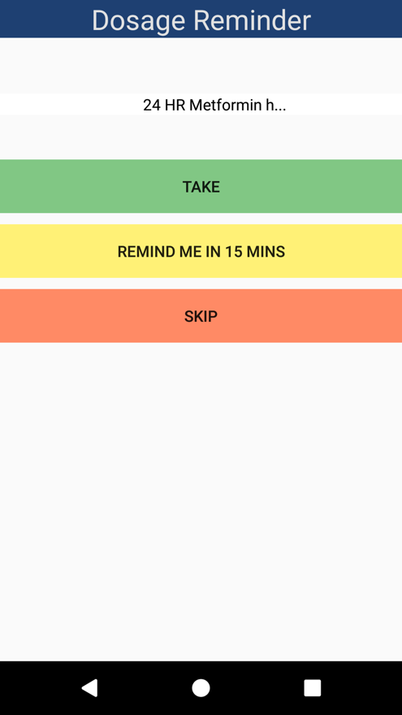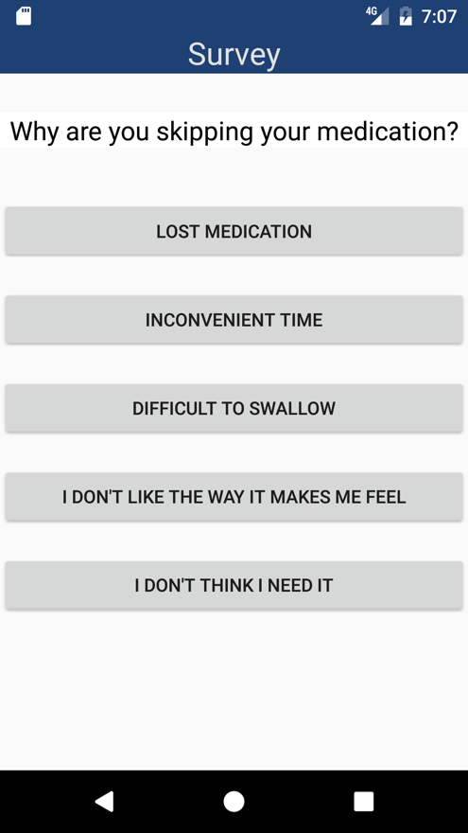

Figure 4: Dosage Reminder and Survey after Skipping Medication

## **Demographic Questionnaire**

* The user also has an option to take a quick demographic questionnaire that may help to determine the user’s medication adherence propensity as well as assist researchers in understanding medication adherence at the community level.
* The questionnaire has a series of 11 questions that the user can answer and submit. The answers will be stored in a database where the researchers can access.
* Once the user clicks submit, the app will take the user back to the main menu.

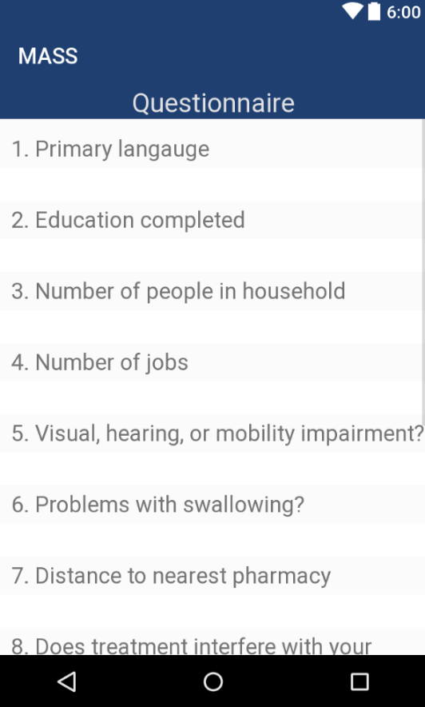 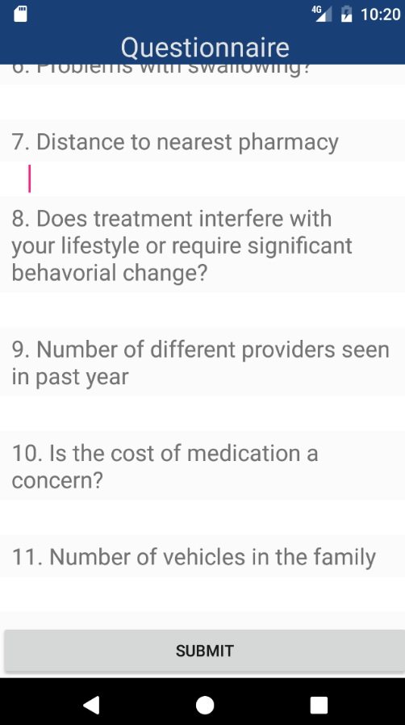

Figure 5: Demographic Questionnaire